**PROJECT DESIGN PHASE-II TECHNOLOGY STACK (ARCHITECTURE & STACK)**

|  |  |
| --- | --- |
| DATE | 22 November 2022 |
| TEAM ID | PNT2022TMID25156 |
| PROJECT NAME | STATISTICAL MACHINE LEARNING  APPROACHES TO LIVER DISEASE PREDICTION |
| MAXIMUM MARKS | 4 MARKS |

# TECHNICAL ARCHITECTURE:

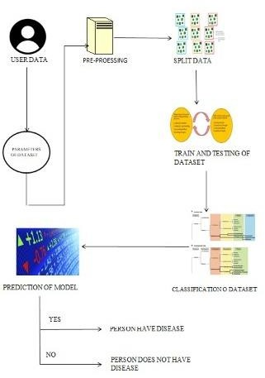

Guidelines:

1. Include all the processes (As an application logic / Technology Block)
2. Provide infrastructural demarcation (Local / Cloud)
3. Indicate external interfaces (third party API’s etc.)
4. Indicate Data Storage components / services
5. Indicate interface to machine learning models (if applicable)

**TABLE-1: COMPONENTS & TECHNOLOGIES:**

|  |  |  |  |
| --- | --- | --- | --- |
| **S.No** | **Component** | **Description** | **Technology** |
| 1. | User Interface | WEB UI | HTML, CSS, Bootstrap |
| 2. | Application Logic-1 | Logic for a process in the application | Python |
| 3. | Application Logic-2 | Logic for a process in the  application | IBM Watson |
| 4. | Database | Data Type, Configurations etc. | MySQL |
| 5. | Cloud Database | Database Service on Cloud | IBM DB2, IBM Cloudant |
| 6. | File Storage | File storage requirements | IBM Block Storage or Local Filesystem |
| 7. | External API-1 | Purpose of External API used in the application | IBM Weather API |
| 8. | Machine Learning Model | Purpose of Machine Learning Model | To predict the desired output by using classification |
| 9. | Infrastructure (Server / Cloud) | Application Deployment on Local System / Cloud Local Server Configuration:  http://127.0.0.1:5000/ | Local host |

**TABLE-2: APPLICATION CHARACTERISTICS:**

|  |  |  |  |
| --- | --- | --- | --- |
| **S.No** | **Characteristics** | **Description** | **Technology** |
| 1. | Open-Source Frameworks | List the open-source frameworks used: | Technology of Opensource framework |
| 2. | Security Implementations | List all the security / access  controls implemented, use of firewalls etc. | Technology used |
| 3. | Scalable Architecture | Justify the scalability of architecture | Technology used |
| 4. | Availability | Justify the availability of application | Technology used |
| 5. | Performance | Design consideration for the performance of the  application | Technology used |